# Introduction

The Danish Flexicurity model is well known worldwide, for being one of the most effective in keeping a low and stable unemployment rate compared to the other European countries (xyz). In 2008 Denmark had the second lowest unemployment rate in Europe, the mechanics of the flexicurity model leading to this result comes from the high level of flexibility coming from the security net in the form of unemployment benefits (Kongshøj). The unemployment benefits ensures that companies can be more flexible as worker unions given the higher benefits demand a lower termination period. (Kongshøj) puts up three main points of view in discussing the perspectives of the Danish flexicurity model. One of them being the deteriorations of the income insurance program, which is argued to be one of the main elements of the Danish flexicurity model, with the other main elements being an active labor market policy encouraging activation and upskilling of unemployed and a flexible labor market. A result of the deteriorations of the income insurance program has been that the workers unions have demanded a higher dismissal protection, in form of allowances when going to unemployment on parts of the private labor market weakening the flexibility.

One way used to quantify the generosity of the flexicurity model is the compensation rate. The calculations of the compensation rate usually consist of the ratio between some type of average level of income insurance for those eligible to a type of average wage for employed, thereby showing the difference in income related to going from employment to unemployment, this is also specified as the gross compensation rate. An alternative to the gross compensation rate is the net compensation rate which is calculated using the disposable income in the two situations of employment and unemployment here effects as taxation changes between being employed and unemployed are included.

In the Danish income insurance program, the income insurance received will be calculated as 90% of the salary subtracted by labor market contributions but can never exceed the maximum level of income insurance set by the government. As the maximum level is set significantly lower than the working income received having a medium - high wage, the gross compensation rate is relatively high for the low-income group and low for the high-income group compared with other countries in the EU. In contrast to other countries, it is not mandatory for workers to be part of an income insurance program, still the insurance rate is quite high, meaning that workers are finding the insurance program attractive. The fact that being part of the program is not mandatory leads to an interesting aspect in that the lower the compensation rates the lesser attractive is the program leading to a lower insurance rate, possibly harming the flexicurity model.

As data from ADAM’s databank suggests the compensation rate in Denmark has been falling since 1990-2018:

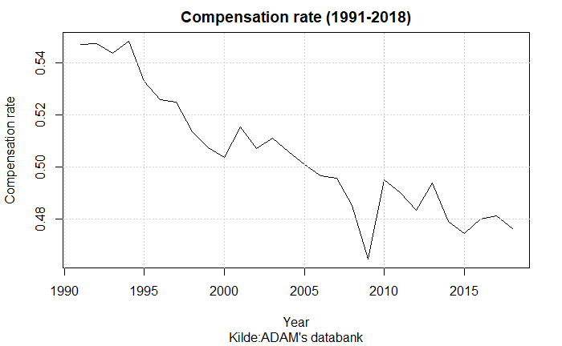

One of the major contributions to the falling compensation rate is the political regulations towards the determination of the maximum level of income insurance. In 2003 the Danish ministry of finance legislated a yearly regulation of unemployment benefits (xyz) The regulation goes through the rate regulation percent which is set to equal 2% each year added by the rate adjustment percent. The rate adjustment percent is each year set according to the adjustment percent which is calculated as the change in wages two years prior to the financial year subtracted by two percent points. If the adjustment percent is lower than 0%, the rate adjustment percent is equal to the adjustment percent. Is the adjustment percent between 0% and 0.3% the rate adjustment percent is 0%. Lastly, is the adjustment percent larger than 0.3% the rate adjustment percent is equal to the adjustment percent subtracted by 0.3 percent points. This creates a situation in which wage growth of more than 2% would result in the maximum level of income insurance not following the wage growth, making the compensation rate decline over time. The plot below gives an idea of how often the wage has increased by more than two percent.

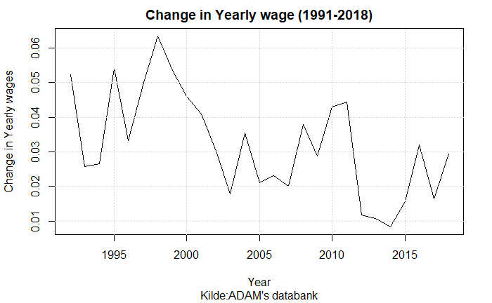

A more recent regulation is the one agreed upon in the Danish tax reform of 2012. One of the political initiatives in this reform was to suppress the regulations of employment benefits in the period of 2016-2023. Starting from 2016 the initiative would create a deduction of the rate regulation rate. The first year (2016) the deduction would be 0.3 percent points, next year 0.4 percent points and in period 2018-2023 0.75 percent points. (Skattereform 2012)

Other studies discuss whether a third reason for a falling compensation rate should be included. Over time a larger share of the wage has been paid to the workers labor market pensions. When calculating the compensation rate the amount paid to labor market pensions from both the worker and employer is subtracted from the wage. Therefor a larger share of the wage paid to labor market pensions will result in a higher rate of decrease in the compensation rate. One of the argumentations for including the development in the share of the wage paid to labor market pensions is that employed will benefit from their pensions later in their lives.   
This third effect is not included in the graph showing the compensation over time, including this effect should up the rate of decrease and thereby make the fall in the compensation rate even larger.

In this paper we will focus on the period of 2005 -2020 within this period other changes were made to the income insurance program. In 2010 a new income Insurance reform was agreed upon, decreasing the period in which an unemployed could receive income insurance from 4 years till 2 years, as well as increasing the requirements for receiving income insurance (xyz). Later, to make the cutoff date less strict updates to the period in which a person could receive insurance were redone making it a smoother transaction from the 4 to 2 years. A more recent change not included in the period of interest is the reform adopted in 2022 making two important adjustments to the program. First, there will be an increase in the amount one can get in the first 3 months for people with a strong working history, the second being a lowering of the amount one can get going directly from education to unemployment. The effects of these reforms will not be included in the analysis. Instead, this paper attempts to analyze the macroeconomic effects of the three effects that seems to be decreasing the compensation rate over time. We use a stock-flow consistent model as this enables us to include the effects of changes in the stocks of for example the households’ pension and government debt, which should be of great interest when assessing the policy regulations.

This paper makes three important contributions. First, we develop an empirical SFC-model integrating the dynamics of the Danish labor market, specifically including the variables that are used for political regulation of the unemployment benefits. Second, we do a counterfactual analysis of the regulations made towards the unemployment benefits. Third, this paper contributes to the ongoing debate of the effects of unemployment benefits on the level of unemployment.

The paper is organized as follows:

# Section 2: Lit review

In the years leading to the Danish election in 2015 the discussion of unemployment benefits was a key topic, especially the income insurance. On the one hand the literature published by the Danish Ministry of employment finds that the gross compensation rate has been almost fixed since the 1990 (xyz). On the other hand, unemployment insurance companies in Denmark, claim that the compensation rate has been falling constantly since the 1990 (xyz). In addition to this the view of which effects and the size of these effects coming from a change in the compensation rate on the economy is also looked upon very differently, resulting in different levels of government expenses and employment when increasing the level of income insurance.

The Danish ministry of employment put down a commission in 2015 to analyze the effects of income insurance in Denmark. Showing the results, they confirm that the rate regulation rate as mentioned in the introduction will lower the compensation rate over time. But when the wage growth increase by more than 2% and the rate adjustment percent is subtracted by up till 0.3% point, this amount is not lost for the unemployed as it goes into the “statspulje” permanently. The funds in the “statspulje” are mainly used for improving the terms for people being on transfer income, thereby (Dagpenge komission) argue that the funds are partly going back to the unemployed.

(xyz) confirms that when taking into account the increasing share of the wage going to worker pensions the calculations show a drop in the compensation rate of 6% point from 1994-2013. They later argue that when analyzing the income insurance, we should in general look away from pension payments, as they have no importance at the moment someone goes from employment to unemployment. They add that the income insurance system should be seen as an insurance against sudden income loss experienced, and not an insurance against loss of lifetime income.   
They further argue that people who are experiencing longer periods of unemployment throughout their life typically will be compensated by “folkepensions persontillæg” and maybe “ældreschek” which is also noted in the pension commission paper (xyz). Therefor the calculations giving the fall in compensations rate of 6% points can’t stand alone. They end up concluding that throughout the period of 1994-2013 the income insurance system has not been made worse of looking at the gross compensation rate.

The paper leaves out the latest of the regulations lowering the state regulation percentage from 2016-2023 that was agreed upon in 2012, this of course wouldn’t change the conclusion for the period 1994-2013 but could have been used for a prediction of how the future development in the compensation rate is expected to evolve.

(LO) in a response to the results of (xyz) mention how the calculations of the compensation rate are sensitive towards which method is used for calculating the compensation rate. It should be added that in their own calculations they use only LO-members. In the calculations of the compensations rate they include the higher ratio of pension payments that (xyz) argued to leave out. They argue that this is an economic gain for being employed, which is supported by the ministry of Finance (xyz), and therefore should be included in the gross compensation rate. Using the net compensations rate the paper argues that not including the increasing pensions would be wrong as people not getting pension payments through their salary would need to save more over time to keep up, thereby lowering their available amount, decreasing the net compensation rate.   
(LO) finds that the gross compensation rate from 1994 - 2018 fell by almost 9% point. If also the changes in the tax system with a falling taxation of the wage bill is considering by looking at the net compensation rate the fall in the same period is around 15% point. Adding to this they argue that the magnitude in the fall will increase over the coming years, as a result of the tax reform 2012, suppressing the rate regulation rate until 2023.

Other similar studies find almost the same results as (LO). For example (FH) when calculating the gross compensation rate, using almost same methods, estimates a fall of 10% points in the period of 1994-2020. (DØRS) follows with a macro-based calculation of the compensation rate using the average amount of income insurance for a full-time unemployed receiver of income insurance, in relation to the average wage in the industry. In addition to this they also add in the development in payments to the worker pensions. They find a drop of approximately 7% points in the period of 1980-2015 when not including pension payments, and a drop of approximately 14% points when including pension payments. The sources leading to this drop is expected to be the same as mentioned above looking at the rate adjustment percentage, the larger share of worker pension payments, and lastly, they expect further drop coming from the suppressed rate regulation rate.

Now knowing that multiple papers using different calculation methods concludes that there has been a fall in the compensation rate which is in contrast with the conclusion of (xyz). There can also be found a large amount of critic of the effects included (and not included) by the commission playing in as a result of increasing the compensation rate. (xyz) use mainly the effects that are included in the ordered literature review (Andersen) to explain the effects of changes in the level of income insurance. They explain most of the effects using behavioral changes looking at the incentive to work. One of the measures is the exit rate, showing how many goes from being unemployed on income insurance, to being employed. The second effect is the approach rate, the idea for this is that the higher the level of income insurance, will create a movement from employment to being unemployed and thereby receiving income insurance. Therefor the main effects from changes in the income insurance level comes from behavioral changes looking at workers and unemployed. A more thorough walk through of how the commission estimates the change in exit rate and approach rate when changing the level of income insurance is given in section 3.

(CEVEA) argues that the behavioral effects (explained above) used to estimating the costs of an increase in the level of income insurance is miss leading. Especially they argue that (Dagpenge komissionen) is overstating the approach effects, stating that increasing the income insurance increases the approach towards unemployment for those employed. (xyz) also themselves states that there is very low empirical evidence for this effect even existing (“Der foreligger en relativt beskeden, udenlandske litteratur, der har undersøgt eksistensen og størrelsen af tilgangseffekter til ledighed.”)  
Also (xyz) add that they don’t see the income insurance at a level where it should be pulling employed into unemployment, they argue that looking at the group experiencing the highest level of compensation rate a large percentage of these are still in job.

A more resent paper by (DØR 2022) concludes that based on new literature the estimate of the approach effect when looking at changes in the level of income insurance is overstating the negative effect that the approach effect has on employment. They split up the analysis into three scenarios one being a change in the level of income insurance, they claim that the reason for the miss leading effect might be that the commission is only including one of four effects that should be playing into the approach effect.

The effect included by the commission, is that people in terminated positions will experience a higher exit rate when lowering the level of income insurance, thereby more people will go into employment before joining the income insurance program. The three other effects that (DØR 2022) argues should be added into the model are the following:

First, (Dør 2022) claim that the commission is neglecting the possible effect of changes in the level of income insurance on job separation meaning a change in the number of “opsigelser” or redundancies. As the higher level of income insurance will lower the costs for a worker losing his or her job. This could lead to a lower effort put in by the worker, increasing the change of the worker getting fired. Also, the fact that a higher level of income insurance could be a chance for the worker to reorganize his or hers working life, increasing the rate in which people go into the income insurance program. (Wang og Williamson, 1996) (Hopenhayn og Nicolini 2009)

Second, the change in level of income insurance could also have an effect on the job creation rate by reducing the number of advertised vacancies, this effect can be caused by higher costs for the firms both because they may have to advertise more if the job search is lower duo to an increase in the level of income insurance, or because of higher wages, as the level of income insurance plays in to the wage negotiations which will be discussed in section 3.

Third, they argue that the income insurance model doesn’t allow the change in behavior of the employed and unemployed can affect other people’s situation. The model is only looking at the individuals expected reaction to change in the income insurance program. As will be seen in section three, newer literature is having a larger focus of the aggregate effects of changes in the income insurance program.

One option to quantify the effects of changes in the compensation rate is by looking at the effect on the government finances, (CEVEA) splits up the effects in two, one being the immediate revenue effect, showing the direct expenses in the form of extra income insurance by for example increasing the level of income insurance, here it is also taken into account that a share of the higher level of income insurance is coming back in the form of taxes and other charges.   
The second effect is mentioned as the behavioral effects or dynamic effects, this is the effect of changes in the exit rate and approach rate, as mentioned above.   
(xyz) splits up the costs for three possible changes to the income insurance program, one of them being a cancelation of the suppressing of the rate regulation percentage for 2021, 2022 and 2023. The estimation of the expenses using the income insurance model created by the income insurance commission suggests that the expenses will be increased by 560% including the behavioral effects, where the exit rate will be contributing with 55% and the approach effect with 45% of the increase. Thereby the total expenses estimated by the income insurance model will be 1090 million kr. (xyz) criticizes the fact that 45% of the increase in expenses are coming from an effect that as mentioned above has no empirical evidence for existing. Adding to this the rules of increasing the level of income insurance states that the membership payments should increase as a percentage of the maximum level of income insurance, this effect would lower the financing needed from the government, and lower expenses. This effect has just recently been added into the income insurance model.

(xyz) argues that not only has the income insurance model been overstating the expenses of increasing the level of income insurance. They have also neglected some of the positive effects of increasing the level of income insurance. They argue that a negative effects of a falling compensation rate is the lower degree of members in the insurance program, in the same period as the fall in the compensation rate, the percentage of the working force being a member has dropped from 84% till 78% even though this period has included political adjustments intended to raise this percentage (xyz). Assuming it will be the people with the lowest chance of losing their job that would want to leave the insurance program this would lead to lower membership payments and a need for a larger financing of the expenses from the government. In addition (DØRS) argues that this in the long run will lead to higher requirements towards termination notices and thereby undermine the Danish flexicurity model.

(FH) puts up multiple possible effects a lower insurance rate would have on the Danish economy: The most convincing one being the longer termination notices, resulting in a lower flexibility on the Danish labor market leading to a higher structural unemployment rate. In general, all these effects lead to the fact that a higher insurance rate increases the security and flexibility of the labor market which strengthens the employment, GDP, and the government finances. (xyz) criticizes the fact that (Dagpenge komissionen) neglects these effects when calculating the expenses of an increase in the level of income insurance and are thereby both overshooting the negative effects and undershooting the positive effects of an increase in the level income insurance.

Lastly, (FH) gives an overview of the government expenses towards income insurance over the years, where among others the falling compensation rate has lowered the net expenses. In 1994 the expenses after including taxes towards income insurance were 25 billion kr. This amount has decreased to 10 billion kr. In 2018, how much of this fall is coming from the fall in compensation rate is hard to tell. As the insurance program have had many other changes in this period as well. In 2018 the income from membership payments going to the government were 6.4 billion, creating a net deficit of 3.4 billion kr. in 2018.

# Section 3

The section above gives an indication that there is a disagreement between income insurance companies and the work of the income insurance commission within both the development of the income insurance program in Denmark, as well as the economic consequences of it. Therefor this section will take a deeper look at the model created by the commission in 2015, and present additional effects that are argued to play in given changes in the level of income insurance.

## Dagpengemodellen

The model of income insurance was developed to analyze effects of political changes in the income insurance program. The model consists of four different parts: A static model for income insurance, a static model for “kontanthjælp”, a Markovmodel and lastly, a re-earning model. The first three parts will be presented now. The re-earning model will not be explained as it only concerns rules for changes in the rules of re-earning the right for income insurance, not looking at the level of income insurance.

The static model of income insurance is developed to calculate the immediate economic effects for a specific person being unemployed when changing the level of income insurance. For this reason, this model will not include the behavioral changes that might happen, when creating changes in the income insurance program.

The static model for “kontanthjælp” is created to give an estimation of the level of “kontanthjælp” a person on income insurance potentially could have received in “kontanthjælp”. Thereby the model can estimate the additionally amount of “kontanthjælp” a person will receive if the level of income insurance is lower than the level of “kontanthjælp”.

The more interesting part is the Markovmodel which is built to calculate the equilibrium levels of employment and unemployment, to do this the population is divided into three groups: Receivers of income insurance, employed, and receivers of other social benefits. Within each group people are further divided into groups based on their “dagpengeanciennitet” (1-208 weeks) and “beskæftigelsesanciennitet” (0-3 quarters). In contrast to the static model for income insurance, it is not possible to follow a single individual.   
The Markovmodel estimates the probability of changing in-between the three groups. As mentioned before the behavioral effects used in the Markovmodel is looking at changes in the exit rate and approach rate, the first Indicating that a change in the level of income insurance changes the departure from unemployment to employment in the period up until the reduction and in the period immediately after. This effect is mostly concerned the unemployed with the best job opportunities to get off income insurance. Estimations from the 2010 reform mentioned in the introduction shows an effect up till 78 weeks before the reduction in income insurance till 26 weeks after, this can be seen from the effect staircase shown below.

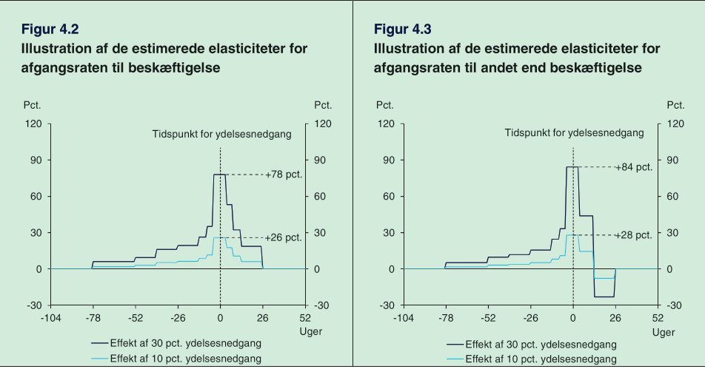

The behavioral effects are specified as elasticities meaning that a relative change in the exit rate from unemployment to employment is a function of the relative change in the gross compensation rate. Thereby the effects of an increase in the compensation rate of 30 and 10% will following their estimates have the effects of increasing the exit rate by 78% and 26%:

Besides the effect of the exit rate on the entire group of unemployed, the commission also includes the approach rate, as mentioned in section 2 the commission only includes one of four effects argued by (DØRS 2022) to affect this rate. The commission looks at if people on their way into the income insurance program will find employment before entering the program. One issue is that data can’t show how many people are on their way to enter the income insurance program or how large their exit rates to employment is.

Therefor the commission must assume that the behavioral effects for people being close to going into the insurance program (fx from terminated positions) are comparable to the behavioral effects of people already being in the income insurance program and thereby have been in unemployment in up till 2 years.

The commission uses this assumption to create a baseline for the exit rate to employment, for employed in terminated positions, more specifically the commission uses a week-to-week basis for looking at people going from income insurance till employment after joining the program.  
To construct the exit rates for people going into the insurance program there is made three additional assumptions:

1. They assume the exit rate is 0% 26 weeks before entering the income insurance program (as there are 6 months of “opsigelseperiode”)
2. The exit rate is assumed to be linear going from 26 weeks before joining the program till the first week of joining the program
3. The exit rate is the same just before joining the insurance program as right after. Meaning the green and red line should meet at week 0

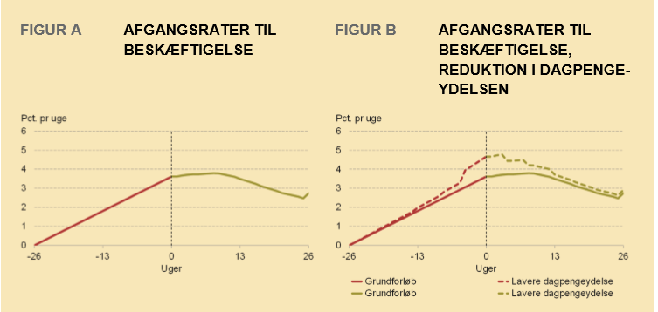

(DØR 2022) Argues that there are missing empirical evidence for all three assumptions made, they claim that people on income insurance might have more time for job searching than people being in terminated positions. On the other hand, they expect people being close to joining the income insurance program to increase their job search to avoid the fall in income.

As seen above the estimated behavioral effects from a 10% decrease in the level of income insurance indicates a 26% increase in the exit rate in the start of the unemployment period This effect is included in figure B by increasing the exit rate by the values estimated from the effect staircase. Meaning a 26% increase in the exit rate in week 0.

From figure B we can now see the effect of an increase in the exit rate for people in terminated positions by looking at the change in the red line showing the change in the exit rate prior to joining the income insurance program. Therefor less will join the income insurance program, when decreasing the level of income insurance. As significant effects are found up till 78 weeks before the change in the level of income insurance for the exit rate, changes in the level of income insurance in the first 78 weeks of the income insurance program will influence the approach rate. (With lower effects the later the increase appears)

## Empirical evidence of the income insurance model

Most of the empirical evidence used for the income insurance model comes from the literature review made by (Andersen) This review was made specifically for the income insurance commission, and therefore influenced the effects used in the income insurance model.

In one of the sections of (Andersen) They look specifically at the literature concerning a rise in the level of income insurance. They present 28 different studies looking at the exit rate from the income insurance program to employment. Looking at an increase in the level of income insurance, they find that 24 of these studies conclude a significant negative effect of the exit rate, the last 4 studies conclude non-significant negative effects.

The two main theories explaining these results are the Moral Hazard effect, and liquidity constraints. The most commonly used explanation for the negative effects is the Moral Hazard effect, where an increase in the level of income insurance will result in lower incentive to search for a new job, and in addition to this also be pickier regarding job offers increasing the unemployment period.

(Chetty) presents the other alternative explanation to why an increase in the level of income insurance increases the period in which people are unemployed. Claiming that unemployed are experiencing a budget constraint, as they are using their savings to keep a higher level of consumption. When one’s savings are running low (which will take longer the higher the level of income insurance), that person might be more likely to accept jobs that are not socially efficient. This effect will thereby lead to a worse job match between employer and employed, not taking advantage of the higher productivity the employer could have had in another job position with a better match. (Chetty) finds that the liquidity effect explains 60% of the effect on the unemployment period from an increase in the level of income insurance.

In another section (Andersen) looks at if there are found any empirical evidence for the effect of liquidity constraints on the quality of a job-match. The effect can arise through heterogeneity for both companies and workers that matters for a job-match. It will take time and costs for both companies and workers to localize a good match. In Addition to this there will be a lock-in effect as there are associated costs of firing/quitting and finding a new employer/employed. This means that workers might not be in the job where they are maximizing their productivity, and reallocation of the working force could therefore lead to a higher output.

Therefor when increasing the level of income insurance, there will be a decrease in job search lowering the employment quantitively, but the quality might increase duo to the above-mentioned effect. (Andersen) presents two measures for the quality of the working force, the salary and hiring period. Theoretically we should look at the reservation salary but as this is not observable studies usually uses different measures of the wage.

(Andersen) presents several studies, all indicating that a more generous income insurance program results in extended unemployment period, approximately half of the studies finds positive effects on the match-quality, the other half finds no effects, and one study find significant negative effects (most of these are from the US and might not be representative).

(Andersen) points out that the above effects have been based on a change in the behavior of unemployed and thereby not taking into account that the change in behavior could affect the situation for other actors in the labor market. At the time of writing (Andersen 2015) mentions that there isn’t much literature looking at these aggregated effects, one of the effects presented is the wage-effect. The wage-effect explains how a change in the level of income insurance will affect the wage negotiations, where you would expect that a higher level of income insurance would increase the targeted wages demanded of the worker unions, to keep a high incentive to work. The literature presented by (Andersen) looks at a micro level, where the wage will have a negative effect as this will lower the demand for labor and thereby reduce the number of unemployed. (ADAM) also includes a link between the compensation rate and the wages, the link goes through the structural unemployment, which is positively affected by the compensation rate, meaning an increase in the compensation rate increases the structural unemployment. In the wage equation the difference between the unemployment and structural unemployment is affecting the wages in the next period negatively. This creates a situation where employment above the structural employment worsens the wage negotiations for workers and thereby negatively affects the wages.

Another study (Mikael, Hamid) uses the framework of a theoretical stock-flow consistent model, also including the compensation rate in the wage equation, together with the rate of employment, and productivity. The inclusion of the compensation rate in a stock-flow-consistent framework is an addition to the model used by (Godley/Lavoie 2012), (Mikael Hamid) Argues that incorporating the compensation rate is in line with standard models of wage setting, which plays an important role in the determination of the targeted wage (xyz).

Maybe shortly mention the insurance rate again, and that many are saying this should be included in the estimates. As ill use it in the next section as one of the effects included. It has already been presented in the previous section though…

In the next section, we will analyze some of the most important effects (argued by the literature) not included in the income insurance model. We want to include the link between the compensation rate and the rate in which people want to be a member of the income insurance programs, this effect is not commented on by (Andersen), but as seen in the section 2, a large group claims that this effect should be included. Next, we will also look at the effect of the maximum level of income insurance on the targeted wage, and how this affects the wage negotiating process. These effects will be included to get an idea of how the suppressing of the rate regulation has affected the Danish economy.

# Model description

The focus of this model will be to analyze some of the effects that the literature argues is missing in the income insurance model created by the (commission 2015) in the decision to suppress the rate regulation percentage starting from 2016. To do so, we utilize the features of a stock-flow consistent framework and build upon the existing empirical stock flow consistent model for Denmark developed by (xyz). The dynamics of the model should be able to explain the macroeconomic effects not included in the income insurance model when analyzing political regulations of the maximum income insurance. This section will focus on the central equations added to include the new dynamics. First, creating a baseline model where only the demand channel is analyzed, after validating the baseline model the wage, productivity, and insurance rate channels are added to the model to analyze the economic effects of each shock. Lastly, we look at a scenario where all the three channels. In all the scenarios we look at the effect of removing the suppressing of the rate regulation percent, in the last scenario we also test a more radical decision to allow the maximum level of income insurance to follow the wage growth one to one.

## Baseline model labor equations

One of the most central inclusions to the labor market equations, is the inclusion of the maximum level of income insurance. Once every year the ministry of finance will set the maximum level of income insurance therefor the variable will only change in the 1. Quarter and stay fixed for the rest of the year. In the baseline model “max_dp” follows the political regulations stated in the introduction. It follows that the maximum level of income insurance grows by the state regulation percentage plus the rate adjustment percentage each year.

As the Ministry of Finance determine the state regulation percentage it is held exogenous in the model. On the other hand, the rate adjustment percentage is calculated each year, using the adaption percentage. To match what was explained in the introduction we need to set up three conditions: First, if the adaption percentage is lower than 0 rate adjustment percentage is equal to the adaption percentage. Second, if the adaption percentage is between 0.0 - 0.3% the rate adjustment percentage is set to 0. Third, if the adaption percentage is above 0.3% the rate adjustment percentage is equal to the adaption percentage minus 0.3% points.   
As with “max_dp” the rate adjustment percentage is calculated in the 1. Quarter and held fixed to the end of the year.

The adaption percentage is calculated by taking the wage growth two years before the financial year subtracted by 2% point, it should be noted that we use the yearly wage growth, which in the model is calculated using the 1. Quarter, therefor the adaption percentage is only calculated for 1. Quarter and held constant for the rest of the year.

The endogenization of “max_dp” is now completed within the model and allows us to calculate the compensation rate within the model estimated as the fraction of the average amount an unemployed on income insurance would receive (dp_person), to the average wage received given employment (wage_ds).

To calculate dp_person we use a simple ols regression linking the maximum level of income insurance to the average benefits received by unemployed eligible for income insurance. This is done as an alternative of using aggregated data of benefits received by households, as the gap between observed unemployment and estimated unemployment in the model is large, creating a lower average of benefits received. We also prefer the regression as we can capture the direct effect of an increased level of maximum income insurance but at the same time, we know that only around 85% eligible for income insurance receive the maximum level meaning that the increase for the people not getting the maximum level would be less. For this reason, we know that the coefficient should be between 0.85 and 1, and most likely closest to 1. This is also observed as the coefficient estimated is 0.9507 observed below.

The average level of income insurance is then transformed into an aggregate variable, multiplying it by the unemployed, and the insurance rate giving the total amount paid in income insurance to the households.

The total amount paid in income insurance to the households then feeds into the households’ disposable income feeding into the production in the economy, this summarizes the demand channel created in the model, not accounted for in the income insurance model.

The total amount of income insurance also feeds into the net lending’s of the government, here it is assumed that the government finances the entire amount, the effect of changes in the level of income insurance will therefor overshoot the effect on government net lending. It is accounted for, that changes in income insurance also affects the taxes coming from households to the government.

One of the key variables in the labor market is the participation rate, showing the ratio of the population being in the labor force. In the baseline model we keep this variable as exogenous, in the second scenario we will then remove this constraint and endogenize participation. A main reason for having the participation rare exogenous in the baseline model is that within the dynamics of the Danish labor market, many have failed to determine what brings people into the labor force. In the income insurance model, the choice of being in the labor force is somehow the same effect captured by the static kontanthjælps model. The idea is that if the income insurance increases compared to the kontanthjælp, more people will actively stay in the labor force. The same concept included in (ADAM) where the compensation rate has positive relationship with the structural unemployment rate, meaning that if the compensation rate increases more people will join the labor force increasing the unemployment rate. In the 2. Scenario this effect will be captured by endogenizing the participation rate and thereby creating a new channel for changes in the maximum level of income insurance through a compensation rate.

## Validation of the model

In this section we look at the performance of the model, comparing the results from the simulation of the baseline model with actual data, with a specific focus on the variables in the labor market.

In the figure below we compare the simulated and actual data for GDP, Employment, maximum level of income insurance, compensation rate, disposable income, and government expenditures.

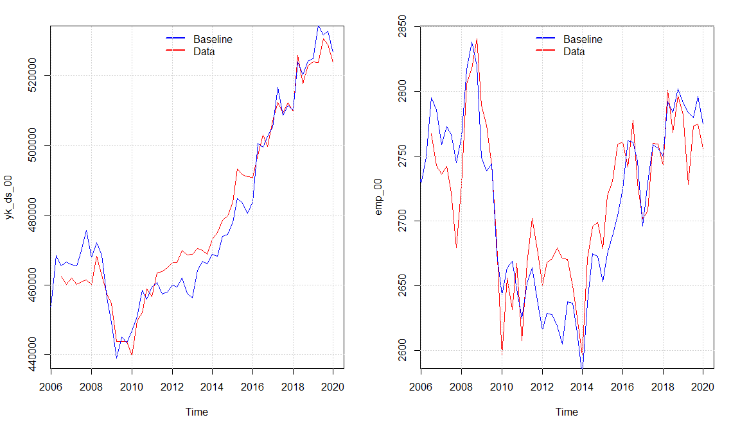

We observe that the model seems to capture the same dynamics of the real economy as (Mikael Hamid) with a small overshooting in the economic activity in the period 2011 - 2016 explained by a higher simulated value of real investment and consumption compared with the data. Overall, the model seems to capture the medium to long-run tendency of the data even though there are some divergences in some quarters. The Overshooting in the activity also results in a higher level of the maximum level of income insurance in the baseline model, resulting from an increase in the wage growth. As the increase in wage growth goes directly into the compensation rate in the same period, meanwhile the maximum level of income insurance will be affected with a lag of 2 years, we observe that the compensation rate is a bit lower around 2010 - 2012, but as the adjustments happens it goes back to follow the real data.

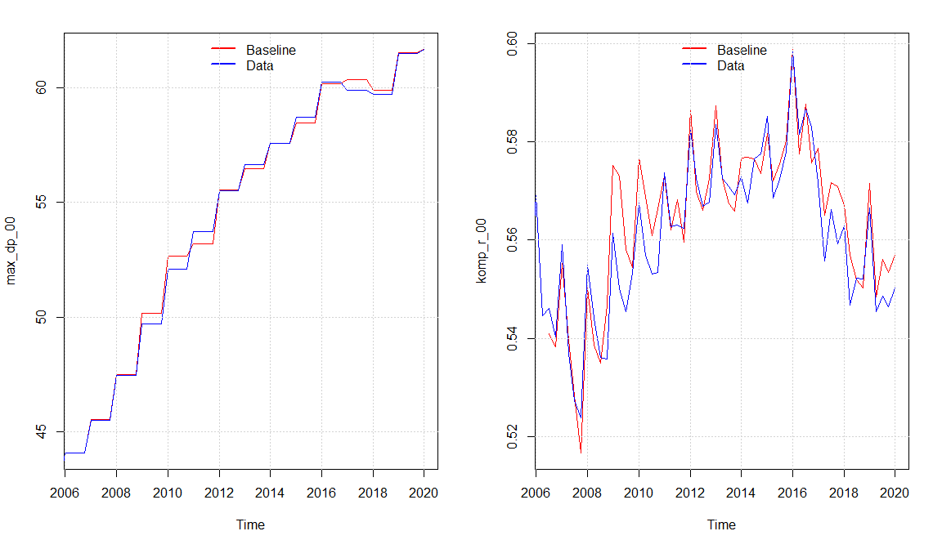

We can see that the compensation rate is slightly increasing, especially from around 2008-2016 (Ser ud til det er grundet aftagende løn, samtidig med at lønstigning inden perioden er høj og dermed påvirker max_dp) comparing with the results of (DØRS 2015) the development fits very well, they as well use a macro-based calculation of the compensation rate. Still, we see a falling compensation rate in the years of suppressing the regulation of the maximum level of income insurance from 2016. Which was also expected looking at the results of (DØRS 2015)

## Scenario 1 No suppressing of the rate regulation percent

In this first scenario we will perform a counter factual shock removing the suppressing of the rate regulation percentage introduced in the tax reform of 2012. Instead, the rate regulation percentage will be held fixed at 2% but still subtracted the rate adjustment percent. As expected, this raises the average income insurance as people having the maximum level of income insurance will experience an increase in their income insurance. The increase in the average income insurance will go directly into the compensation rate. Both increase by approximately 3.5% in the period of 2016-2023, which can be seen below.

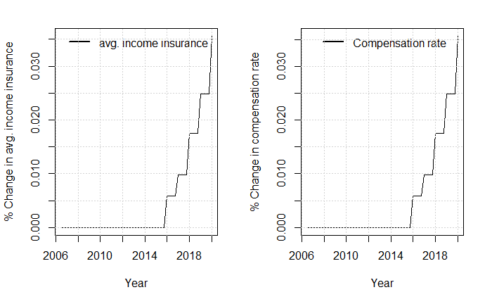

The increase in the average level of income insurance, increases the net social benefits received by the households, and thereby raises the disposable income of the households. As the increase in net social benefits for the households are financed by the government the net lending of the government will fall. These effects take into account the increased tax payments that the households will experience.

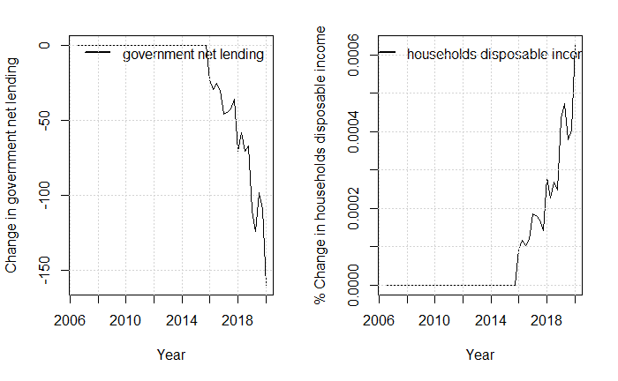

The increase in disposable income increases the consumption and therefor also the GDP. The increase in GDP will increase the firms demand for jobs and thereby raise employment.

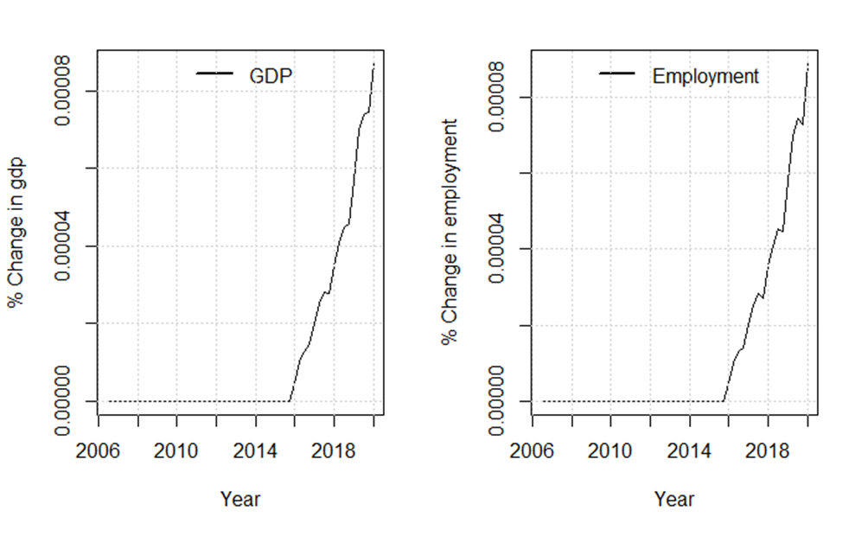

The only effect of removing the suppressing of the rate regulation percent in scenario 1 goes through the demand channel. As it is only a minor part of the population experiencing an increase in income, the macroeconomic effects are minimal but seems to expand the economy. Calculating the change in employment coming through the demand channel we get that employment increases with approximately 250 people. In the next scenario a wage channel will be added to the model while still creating the same counterfactual scenario in removing the suppressing of the rate regulation rate.

## Scenario 2 Including income insurance in the wage negotiations

Besides the channel in which a higher level of maximum income insurance stimulates the economy through a higher demand, it also plays into the wage bargaining dynamics, as presented in section 3. The wage bargaining in the model is created through a targeted wage (wage_ds_t) which is set by the labor unions going into the wage negotiations. The labor unions got two agendas when determining the target wages. First, they want the wage to follow inflation so that workers keep their purchasing power over time. Second, they set a threshold for the minimum wage gap, in the model this is 40% of the wage, they would want to keep this gap between the wage and the maximum level of income insurance, to make sure that there will still be a strong incentive for people to go into employment. In the case where inflation is not able to close this gap alone (thereby leaving the gap to be below 40% of the wage), the labor unions would set the target wage so that the wage gap is exactly 40% of the wage. The equation for the target wage and the wage gap can be seen below:

The targeted wage is then included in the behavioral equation determining the wage, estimated to have a positive effect on the wage in the long run.

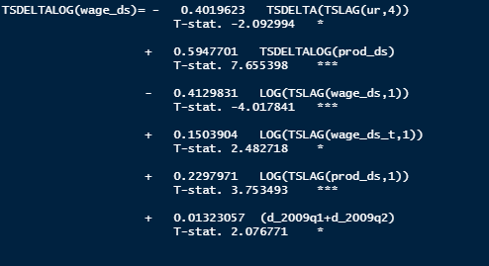

Performing the same shock as in scenario 1 by removing the suppressing of the rate regulation rate, we see that the targeted wage increases by almost 0.6% when introducing the shock to the right in the plot below that the wage gap now increases as the duo to the increase in the targeted wage, but ends under the scenario 1 wage gap, the reason for this is that the wage is now higher lowering the ratio.

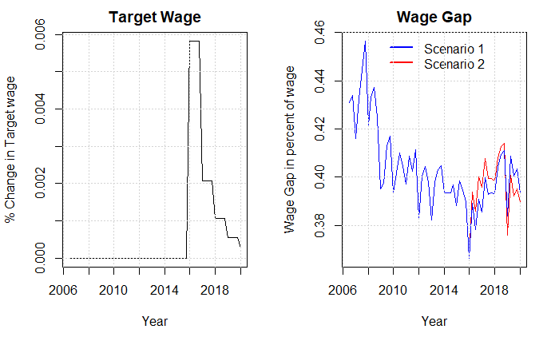

This effect happens as we see the wage negotiations are affected of the increase in the targeted wage, and thereby increasing the wages, as the firms are now experiencing higher costs, this will go into the consumer prices.

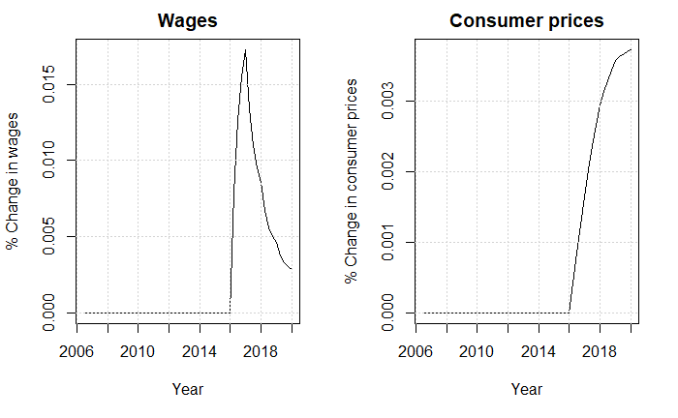

The increase in prices will increase the real exchange rate lowering the export, we see this effect on the net balance right after the shock. After decreasing it start to bounce back and in 2020 ends above the baseline model. The reason for this is that import is falling even more than the export in the end of the period, duo to a fall in the economic activity.

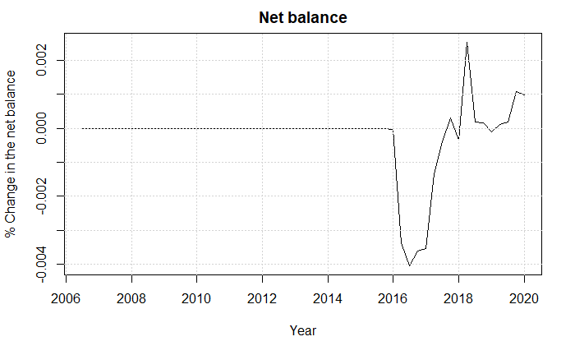

To analyze why we see a fall in the economic activity we start by looking at the consumption and investment. We observe a fall in the investments, as the wages increase, this creates an increase in the wage share and thereby lowering the profit share. As the profit share goes directly into the investments of the firms this decreases the future investments

The consumption increases in the start of the period as the higher wages results in a higher disposable income, and thereby increasing the consumption.

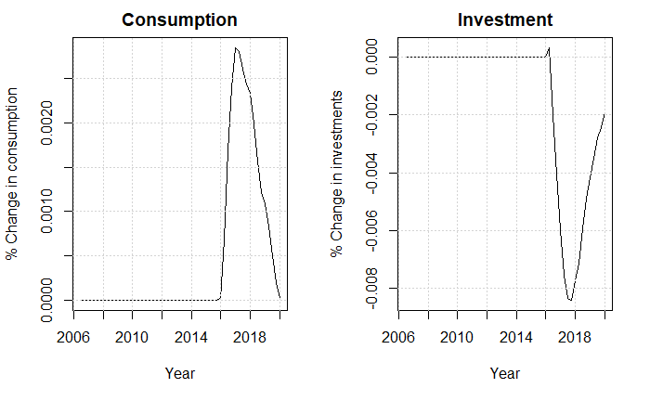

As the government spendings are exogenous in the model this has no effect in the model. Therefor we can conclude that the fall in investments is larger than the increase in consumption and trade balance therefor decreasing GDP and employment. The fall in employment as a result of removing the suppressing of the rate regulation rate is a fall of approximately 100 people in 2020. In the next section we will add a new channel in affecting the insurance rate.

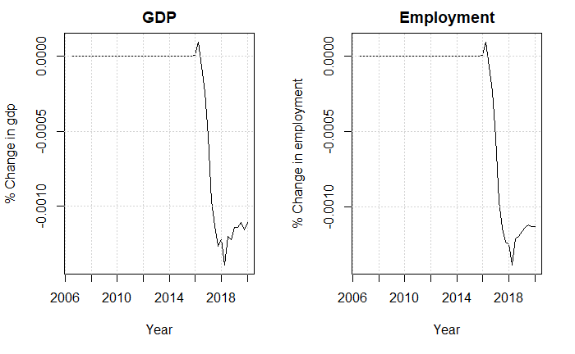

## Scenario 3 Effect of compensation rate on the insurance rate

In the baseline model the insurance rate is set exogenous, but as many of the critics of the income insurance model argue the compensation rate should impact people’s choice to join the program. The literature mentions that we should expect the workers with lowest chance of becoming unemployed to be the first to pivot away from the program duo to a falling compensation rate, this effect will not be included in the model. Still there will be an effect on the demand site of the economy when a higher percentage receives income insurance when unemployed. The equation added to the model can be observed below:

It should be noted that the data for the percentage of people being a member of the income insurance program is based on data from ADAMS databank, therefor we only estimate the equation till 2017 quarter 4 as the variable is constant after this period. We find a positive long-run relationship between the compensation rate and the insurance rate, the results are significant at a 10% significant-level.

Comparing the effect of the shock from scenario 1 and 3 we start by looking at the benefits received by the households, we see that the increase in compensation rate increases the incentive to join the insurance program thereby a higher percentage of the unemployed will be receiving income insurance increasing the net benefits received by the households.

When the net benefits of the households increase the net lending of the government will decrease, as it is assumed that the government is financing the increase in income insurance paid to the households.

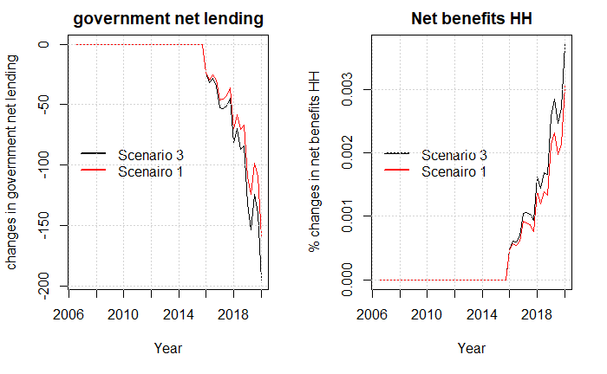

It shows that endogenizing the insurance rate, increases the demand effect an increase in the level of income insurance has, as well as in scenario 1 we see an increase in the level of GDP comparing with the shock in scenario 2 in the plot below.

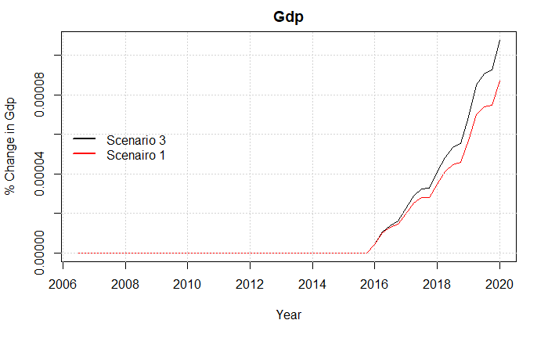Lastly, we can look at the effect of employment and the unemployment rate where we can see that the effect increases the employment and lowers the employment rate.

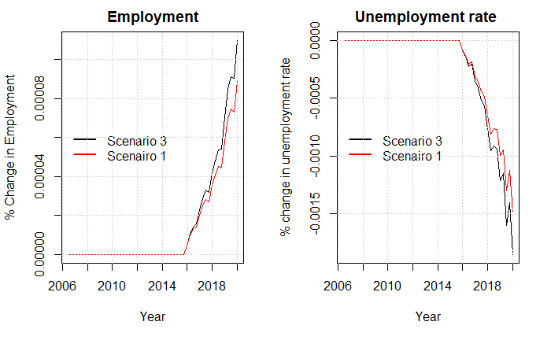

## Scenario 4 effect of maximum level of income insurance on participation

The endogenization of the participation rate happens with a few changes in the model. For now, the participation rate is exogenous and goes into the function defining the labor force as a fraction of the overall population.

The development in the participation rate has over the years been “biased” as a result of an increasing ratio of older people in the population. Therefore, we created a new participation rate only looking at the population below 65 years of age. The difference in the two participation rates can be observed by the figure below, with the figure on the right-hand site being the newly calculate participation rate.

We can see a difference in the trend of the two variables, where the participation rate of the population being younger than 65 years slopes upwards. As mentioned in section 2 and 3, the income insurance model considers the relationship between “kontanthjælp” and income insurance when determining whether to stay at the labor market. The same type of argument is used here where we include the ratio between “kontanthjælp” and the avg. level of income insurance received by households. The other explaining variables being the real wage and the unemployment rate, following the work of (Mikael Hamid). This creates a new channel for max_dp to affect the economy as an increase in max_dp will increase the avg. income insurance and thereby lower the ratio of kontanthjælp to avg. level of income insurance. We find a negative relationship between the kontanthjælps-ratio and participation-rate in the long run, indicating that people would rather stay in the labor force when the income insurance is high compared to benefits outside the labor force in the form of kontanthjælp.

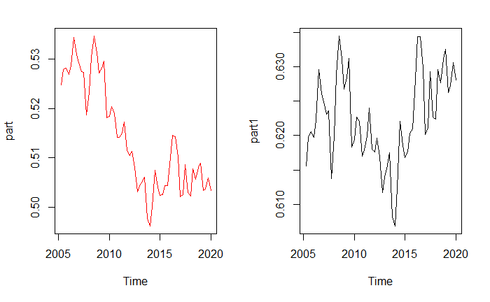

In the graph bellow we can observe the participation rate for the entire population before and after the endogenization of the participation rate, when performing scenario 1. We observe that the participation rate increases, as more people are actively searching for jobs when the level of income insurance is larger.

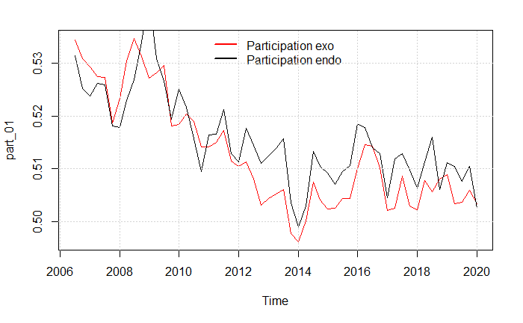

Not sure I will be including this shock as it only creates fluctuations but no real changes in the shock

Please look at graph below

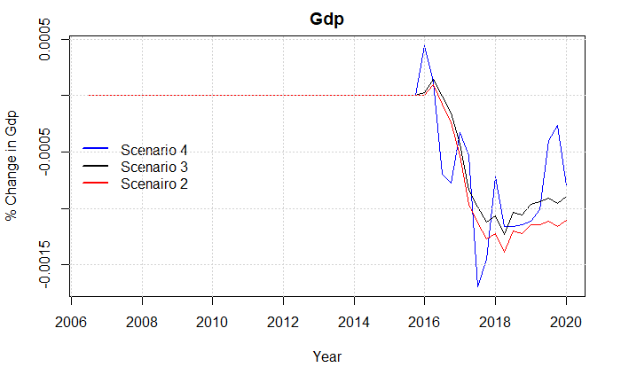

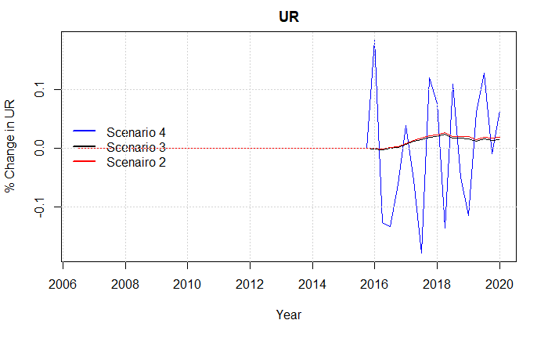

## Scenario 4 Including the matching effect

## Scenario 5 Wage adjustment in maximum level of income insurance

We can see from the previous scenarios that including the additional effects doesn’t create large changes in the economy, therefor we will now introduce an additional shock together with adding all the channels in the economy discussed so far.

In this scenario we change the equation for the maximum level of income insurance, so that it follows the growth in wages from two years before the financial year. Therefore, this scenario will show the counterfactual situation in which the regulation from 2003 doesn’t appear, which means increases in the maximum level of income insurance will no longer be subtracted by up till 0.3% each time the growth in wages exceeds 2%. Also, the regulation from the 2012 tax reform is removed in this scenario as in the prior scenarios. The new equation for the maximum level of income insurance takes the following form:



We keep using the wage growth two years before the financial year for consistency, as the (quit large) increases in 2003 and 2004 would inflate max_dp in the baseline but not in this scenario. As a result of the shock, we would expect max_dp to increase even more than in scenario 1. As can be seen from the graph below max_dp increases by almost 6% from 2006q3 till 2020q1. We see that it is mostly coming of the removal of the suppressed adjustments in the unemployment benefits, isolating this effect can be observed from the last figure.

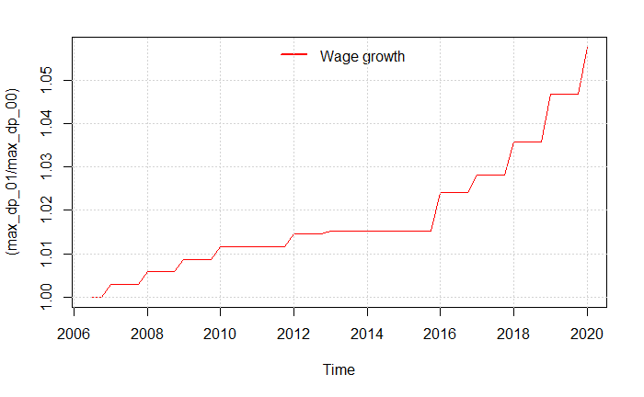

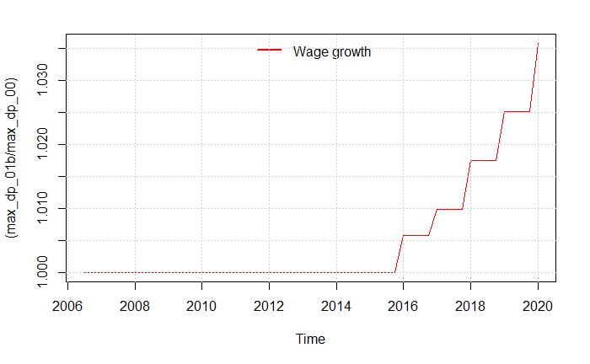

We can see that the increase in the maximum level of income insurance is now two percent points above scenario 1. We will now look at the difference in the macroeconomic effects of the larger increase.

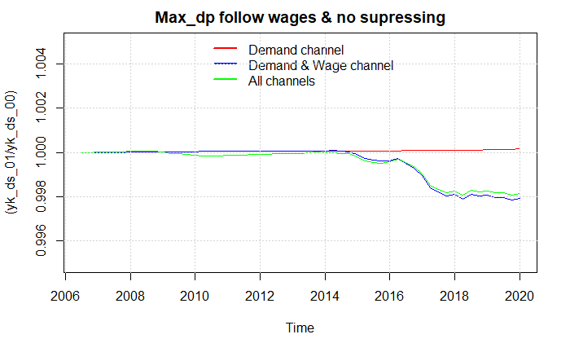

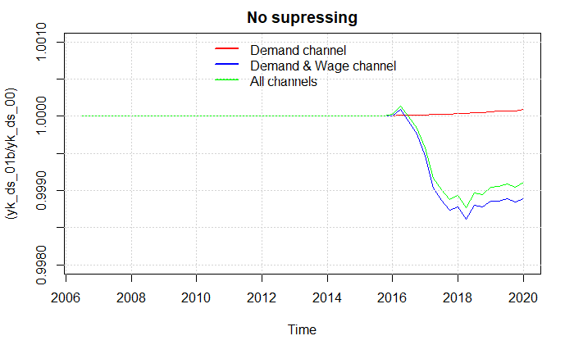

From the two plots we can see that the effects are slightly higher when letting the maximum level of income insurance follow the wage growth. But the overall effects turn out to be the same.

## Sensitivity analysis

In this section we will perform a sensitivity test of the most influential parameters in the shocks. First, we will look at the estimate going into the equation of the average income insurance when performing the shock in scenario 1. We know that the estimate should be between 0.85 and 1 as the fraction of receivers of the maximum level of income insurance is 0.85. And no more than 100% can receive the maximum level.

Therefor we will test the effect of lowering this estimate to 0.85 assuming that only the people on maximum level of income insurance will experience the increase. On the other site most of the increases in the maximum level of income insurance comes from wage increases, which will also increase the level received by those not hitting the maximum level of income insurance, therefor we increase it to 0.99.

### Estimate of 0.85

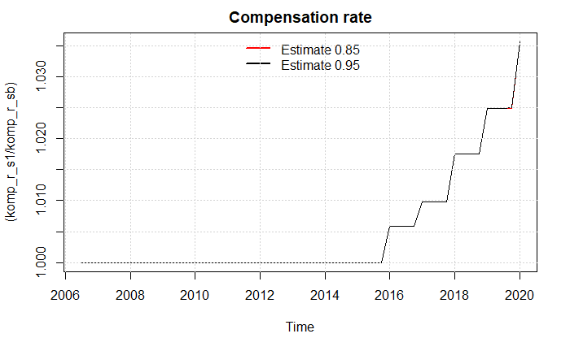

Seems like the magnitude of the shock is the same in the two scenarios which makes since I guess, as the baseline should be lower to start with?

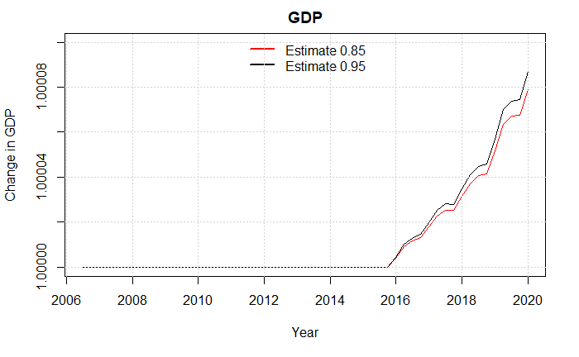

I think the increase in demand is lower because of its an increase in the dp_person of the same magnitude, but a lower number?

### Estimate of 0.99

# Behavioral equations estimated

## Participation

## Wage_ds

